Residential Generators
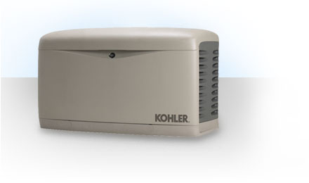
Your home is a busy place. And a commercial-grade KOHLER automatic home generator keeps that rhythm going by providing dependable protection during unexpected power outages. Available with 8.5 to 100kW output capabilities, KOHLER home generators provide worry-free emergency power to support your electrical needs for days, or even weeks. Clean, quiet, automatic backup power - just what your family needs to be safe and comfortable.

Automatic, hands-off operation
In the event of a utility power outage, the transfer switch - working in tandem with the generator - automatically starts the generator to restore power to the home, whether you're home or away.

Fast backup power
KOHLER home standby generators restore power within 10 seconds of an outage.

